**Ideation Phase**

**Brainstorm & Idea Prioritization Template**

| Date | 31 January 2025 |
| --- | --- |
| Team ID | NM2025TMID03158 |
| Project Name | Educational Organization using ServiceNow |
| Maximum Marks | 4 Marks |

**Brainstorm & Idea Prioritization Template:**

Brainstorming provides a free and open environment that encourages everyone within a team to participate in the creative thinking process that leads to problem solving. Prioritizing volume over value, out-of-the-box ideas are welcome and built upon, and all participants are encouraged to collaborate, helping each other develop a rich amount of creative solutions.

**Step-1: Team Gathering, Collaboration and Select the Problem Statement**

Our team identified a real-world problem that can be automated using ServiceNow. After discussion, we chose “Educational Organization Service Automation” as our project topic.Many student and administrative services in educational institutions are still handled manually, causing delays, repeated visits, and lack of status tracking. To solve this, we developed a centralized ServiceNow portal that allows students and staff to submit requests, track progress, and receive updates digitally.

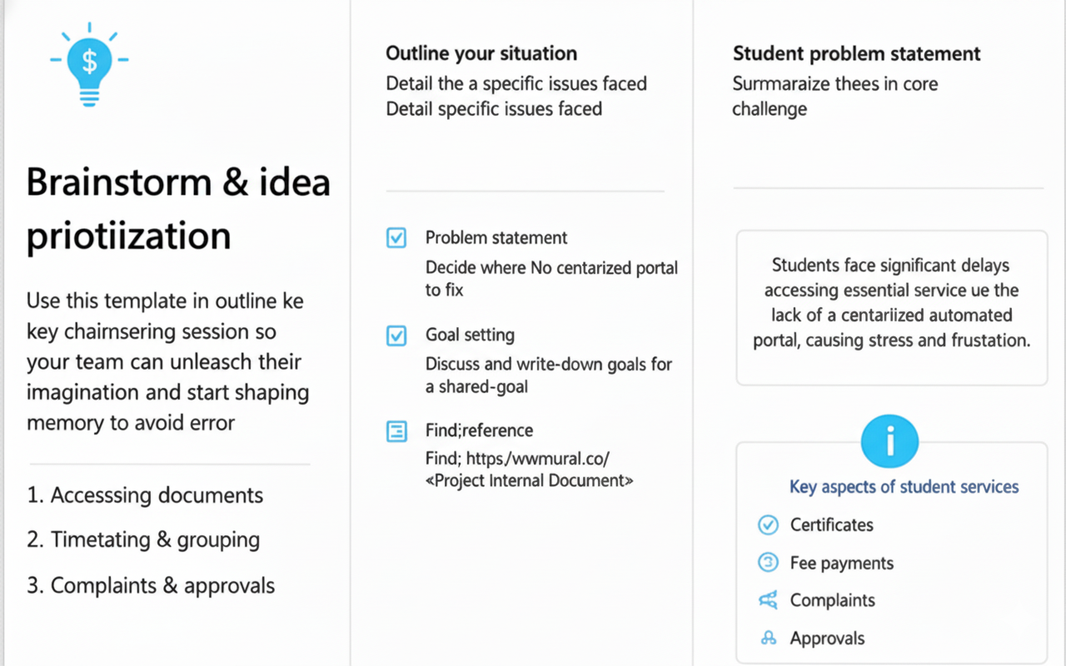

**Step-2: Brainstorm, Idea Listing and Grouping**

We listed all potential ideas for developing the system using ServiceNow. Each idea was discussed, grouped, and evaluated based on feasibility, usefulness, and impact on campus operations.

Ideas generated included:

* Creating a centralized student service request portal in ServiceNow
* Providing online request forms for certificates, ID card, fee queries, hostel/transport, and bonafide
* Automating workflow approvals for academic and administrative requests
* Enabling real-time request tracking and automated status notifications
* Generating dashboards and reports for students and administrators
* Providing knowledge base/articles for student self-service

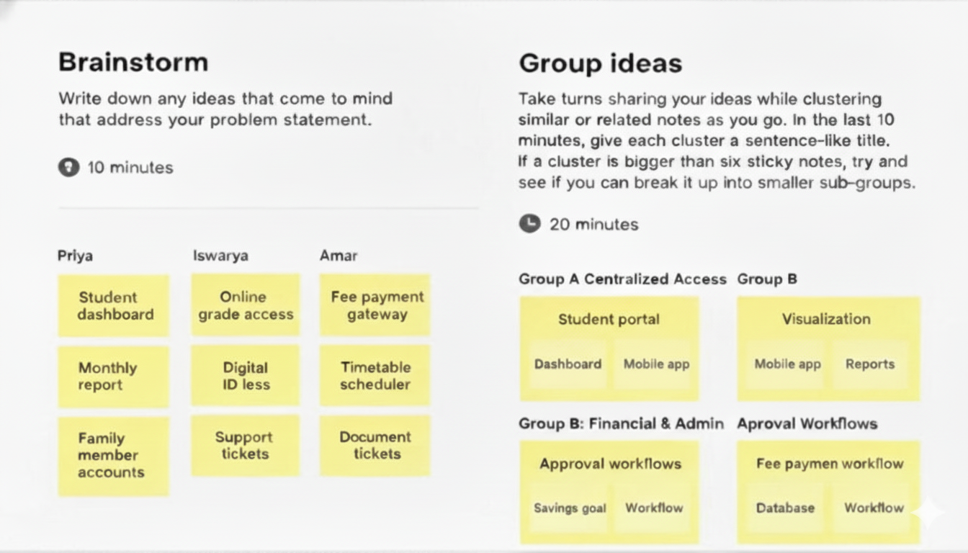

**Step-3: Idea Prioritization**

After listing all ideas, we applied prioritization techniques such as impact vs. feasibility analysis. We selected ideas that provide the highest value to students and administrators while being easy to implement in the initial phase.

Prioritized ideas:

1. Centralized student request portal
2. Online forms for academic & administrative services (certificates, ID card, hostel, transport, fee queries, etc.)
3. Automated approval workflows for student service requests
4. Real-time request status tracking and notifications
5. Dashboard for administrators and students to track requests

